Jenkins Project:

PIPELINE FOR DEPLOYMENT:

1. CREATE A JENKINS SERVER

2. CREATE 2 SLAVE AND ATTACHED TO JENKINS (Master-slave)

3. INSTALL TOMCAT ON SLAVE

4. CREATE NEXUS SERVER

5. INSTALL DEPLOY TO CONTAINER PLUGIN

5. WRITE PIPELINE

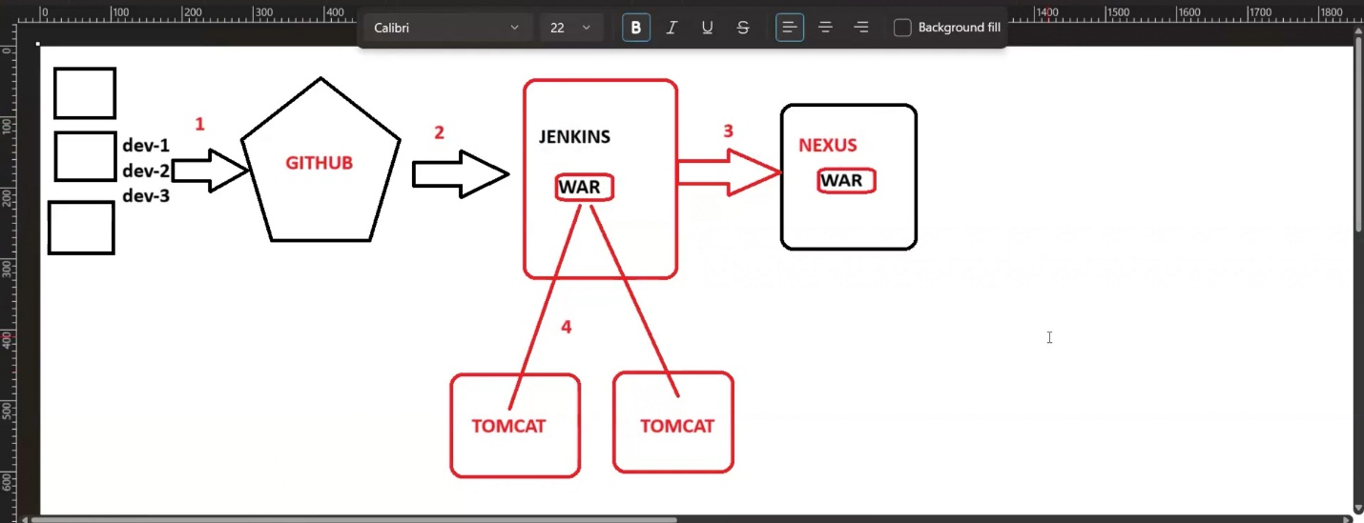

Steps:

1.CREATE A JENKINS SERVER

2. CREATE 2 SLAVE AND ATTACHED TO JENKINS (Master-slave)

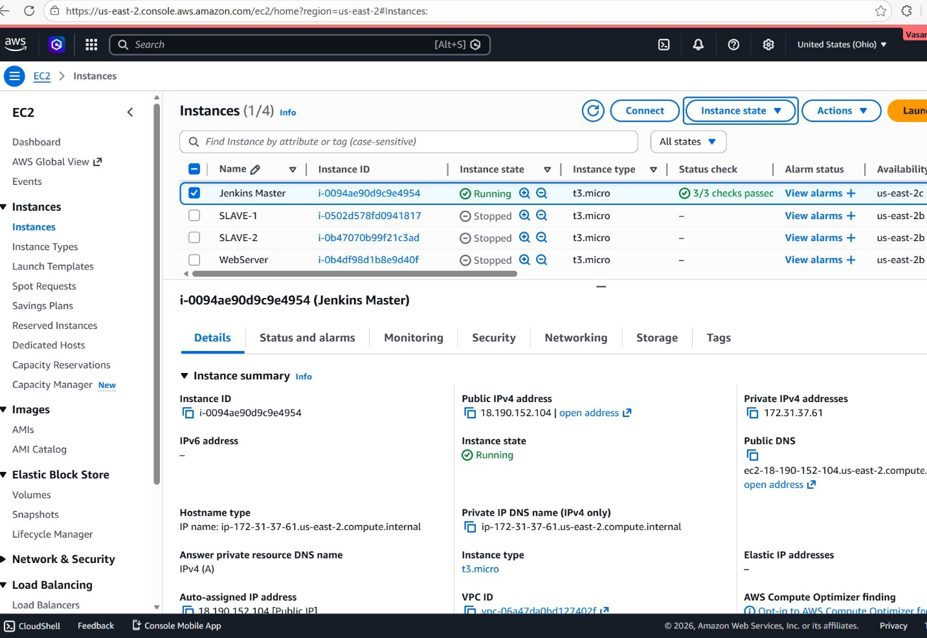

3. INSTALL TOMCAT ON SLAVE

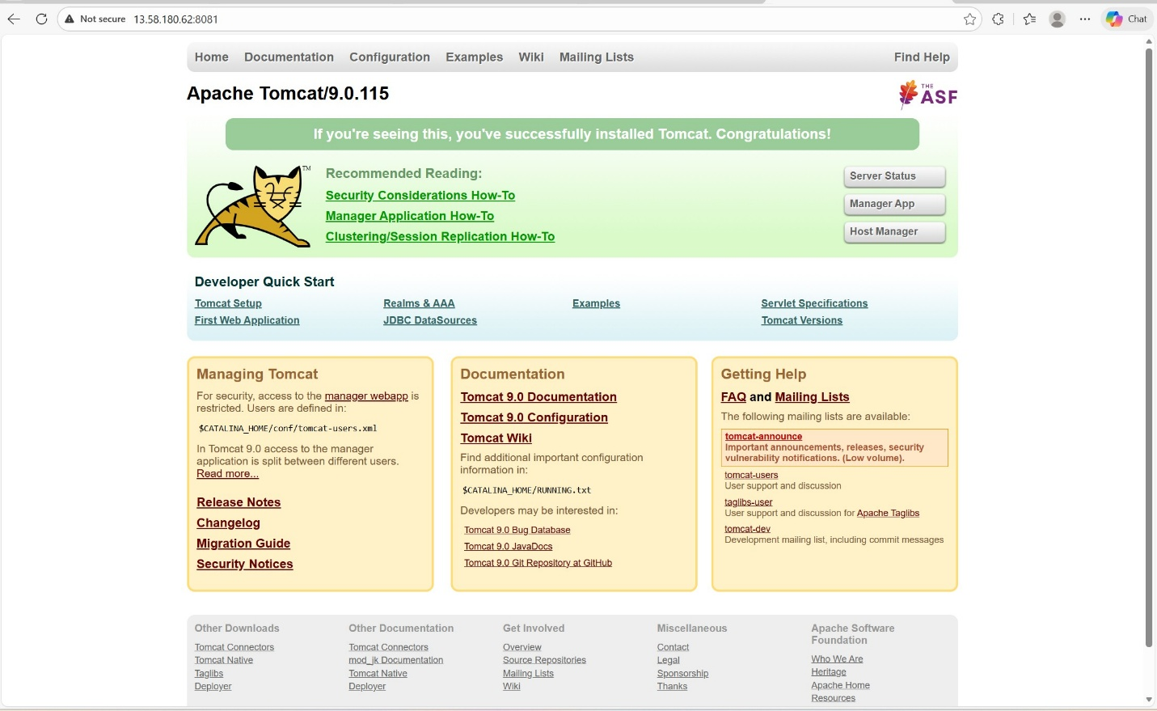
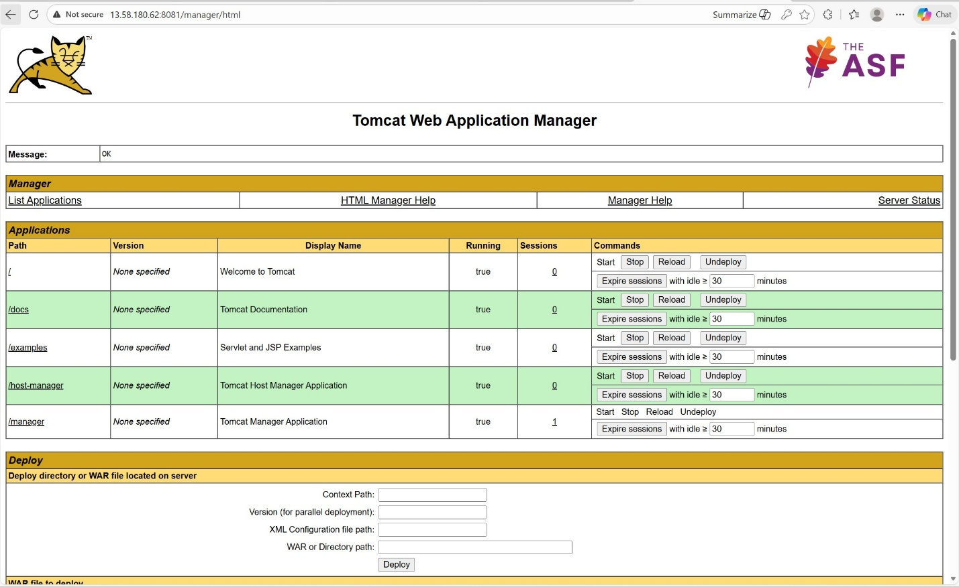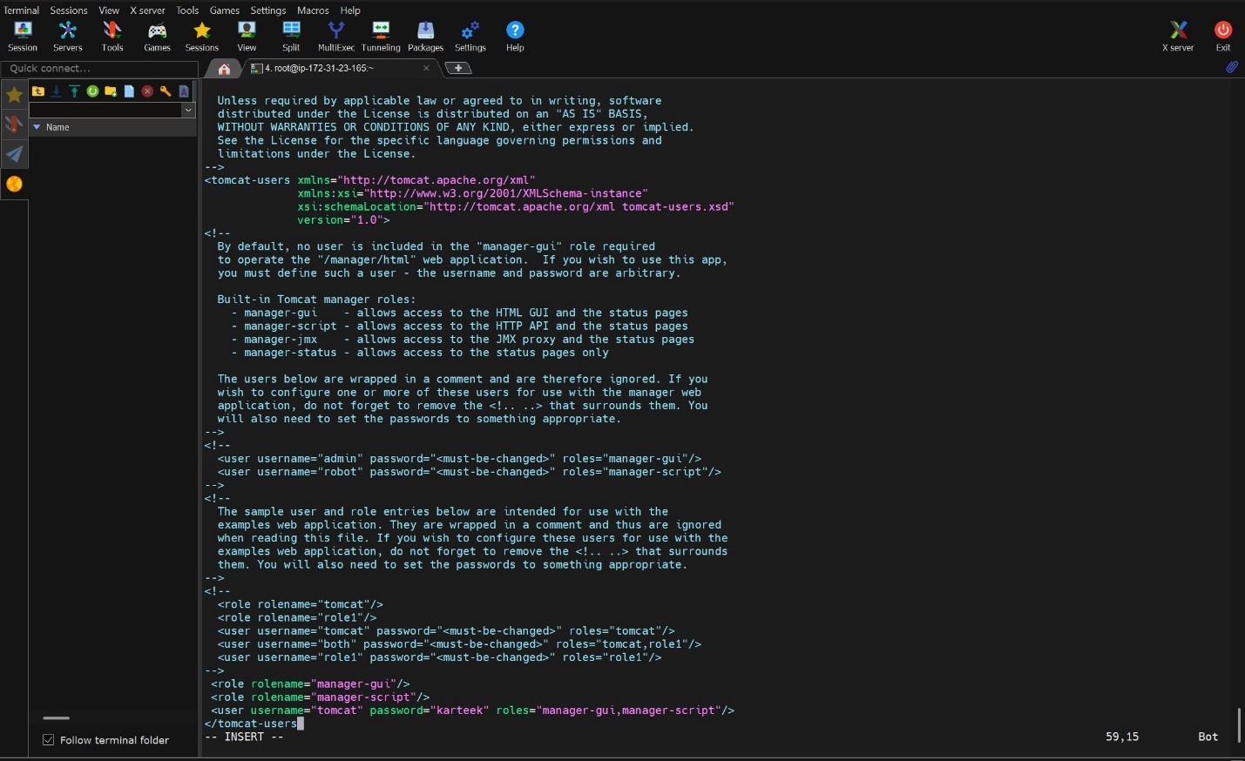

4. CREATE NEXUS SERVER

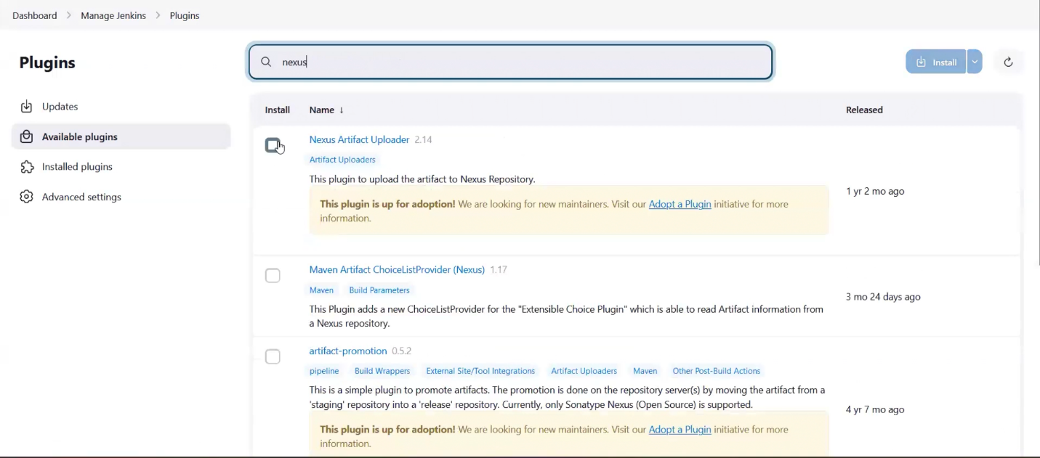

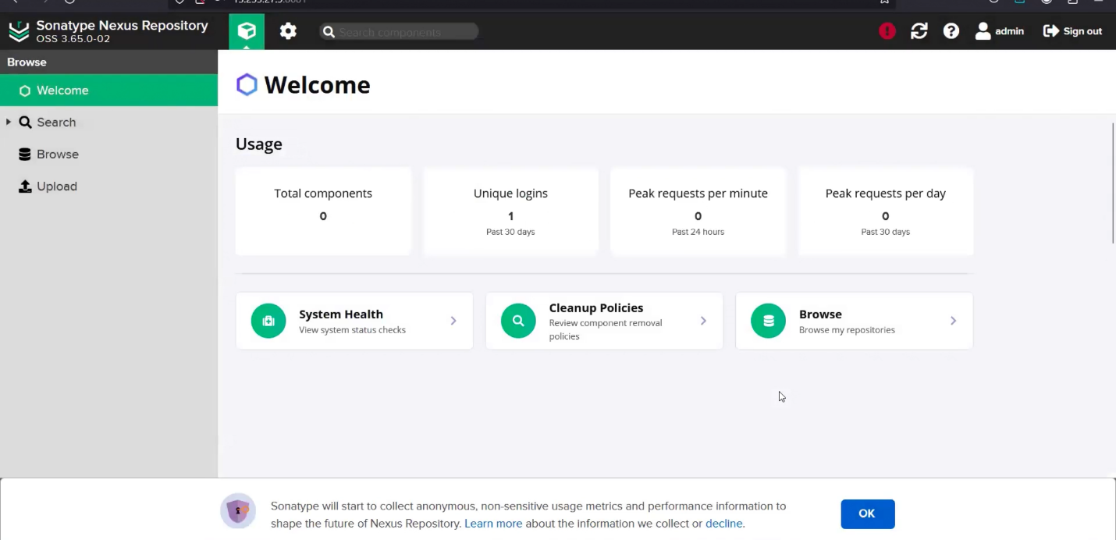
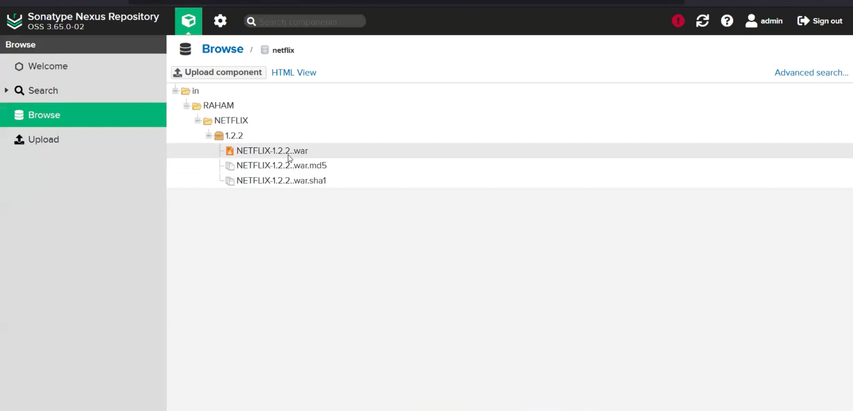

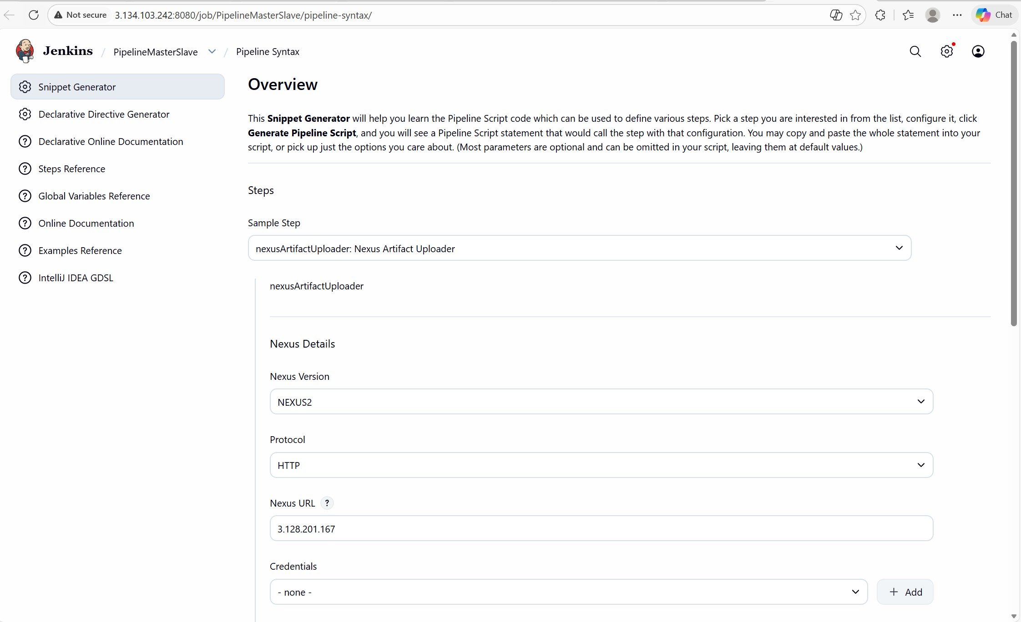

5. INSTALL DEPLOY TO CONTAINER PLUGIN

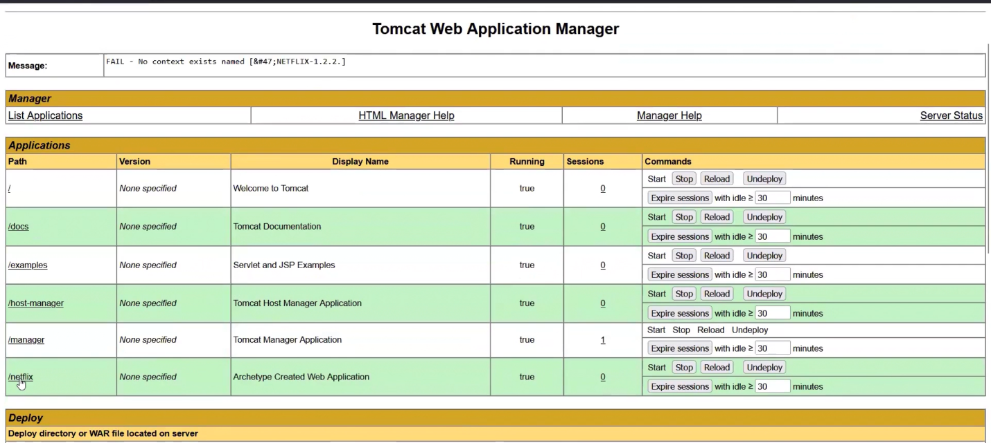

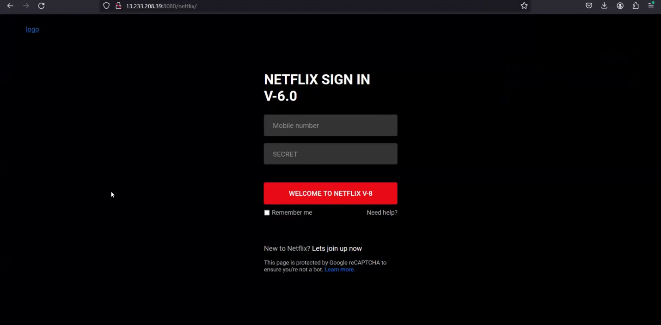

Pipeline Script:

pipeline {
agent {
label 'one'
}

stages {
stage("checkout") {
steps {
git "https://github.com/chriskarteek/jenkins-java-project.git"
}
}
stage("build") {
steps {
sh 'mvn compile'
}
}
stage("test") {
steps {
sh 'mvn test'
}
}
stage("artifact") {
steps {
sh 'mvn package'
}
}
stage('deployment') {
steps {
deploy adapters: [
tomcat9(
credentialsId: '47f1990b-7b77-435c-891c-bf36285b8338',
path: '',
url: 'http://3.142.209.31:8081/'
)
],
contextPath: 'netflix',
war: 'target/NETFLIX-1.2.2.war'
}
}
}
}

